Moneer Elmasseek
Email: moneerelmasseek@hotmail.com
Website www.moneer.co.uk
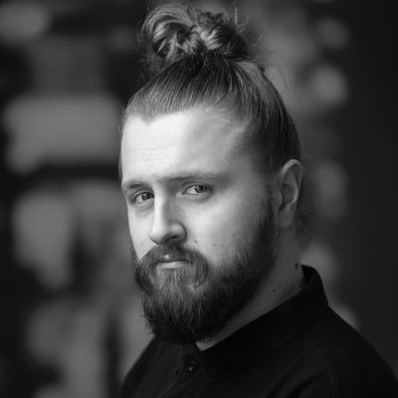
Location: London, United Kingdom
Height: 6”2 Build: Slim Hair: Blond, Shoulder Length Eyes: Blue
Accents: English (Native), Cockney, RP, USA Southern, Russian.
Age: 27
Role playing age: 20-35 (Shaven/Unshaven)
Spotlight PIN: 1815-8944-2108
Training:
2014 – 2015 “Future Stage” - Generation Arts
2012 – 2013 Central School Of Speech and Drama.
2008-2012 City and Islington college (BTEC Intro, First and Extended diploma in Performing arts acting).
2009-2010 National Youth Theatre (Work shop).
TV, Film and Theatre Credits:
Year Type Role Production Company Director
Theatre:
2020 Play -Badger - “The Wind in the Willows interactive” – A wonderful Adventure – Hallie Darling
2019 Play - Hedgehog - “The Wind in the Willows” - A wonderful Adventure – Hallie Darling
2018 I-Theatre – Prince Harry - “The Royal Wedding” - Merlin - Boe O'Brien
2017 Play - Zyncboy84 - “The Court of Smiles” - The EL Shakespeare Company – Stefano Guerriero
2017 I- Theatre - Edward Bates - “1605” - London Dungeon - Richard Quincey
2016 I-Theare - Shrek - “Shrek's Adventure” - Dreamworks - Kevin Haney
2016 Play - Andrew - “The Duke and the Architect” - Etcetera - Domminic Cannon
2015 Play - Lancelot - “The Merchant of Venice” - The EL Shakespeare Company – Jessie Ayertey
2015 Play – Geoffrey - “Dirty Special Thing” - Generation Arts - Ali Godfrey
2015 Play – Jimmy - “Together” - Generation Arts - Ali Godfrey
2014 Play - Gregory - “Romeo and Juliet” - The EL Shakespeare Company – Joe Hughes
2013 Play - Godfrey - “Black tongues tell white lies” - The next Chapter - Spencer Kennedy
2013 Play - Dad - “Best of Both Worlds” - Angel Shed - Lorraine Gout
Film and Television:
2021 Television Drama – Thomas Barrow – “The Lost Pirate Kingdom” – Netflix – Hereward Pelling
2020 Short Film – Corvus - “The Raven” - Monsteers Artistry – Kyra Jessica Willis
2020 Short Film – Dr Jekyll/ Mr Hyde – “The Tweedle Twins” – N/A- Moneer Elmasseek
2019 Short Film - Ben - “The Betrayal” - N/A - Moneer Elmasseek & Drou Cobstantinou
2018 Short Film - Soldier - “Candle” - JakeMcNeilFilms – Jake McNeil
2018 Student Film - Homeowner - “Outbreak” - N/A - Megan Murphy
2017 Television Drama - Kyle Jesmond - “Silent Witness” - BBC - David Drury
2016 Docu-Drama - Alexander Rodchenko - “Revolution” - BBC - Margy Kinmonth
2014 Short Film - Steven - “The Memory Box” JakeMcNeilfilms - Jake McNeil
Commercial
2018 Viking - “Shakti-Matt” - “Shakti-Matt - Glynn Ryland
2017 Dothraki - “NowTV” - “WCRS” - Mark Denton
2017 Security Guard - “ALIEN: Escape” - 20th Century Fox - Emily Parsons
2013 Tied up Man - “Speedy Cash Loans” - London Media - Tina Mondas
Skills:
Script Writing, Creative writing, Stage Management, Directing, Stage Combat, Horse Riding, White Crane Kung Fu, Improvisation, First Aid, Aquatic First Aid, Kayaking , canoeing, swimming, Photography.
Music Skills
Comical singing skills, West African Drums, Children’s entertainer.

